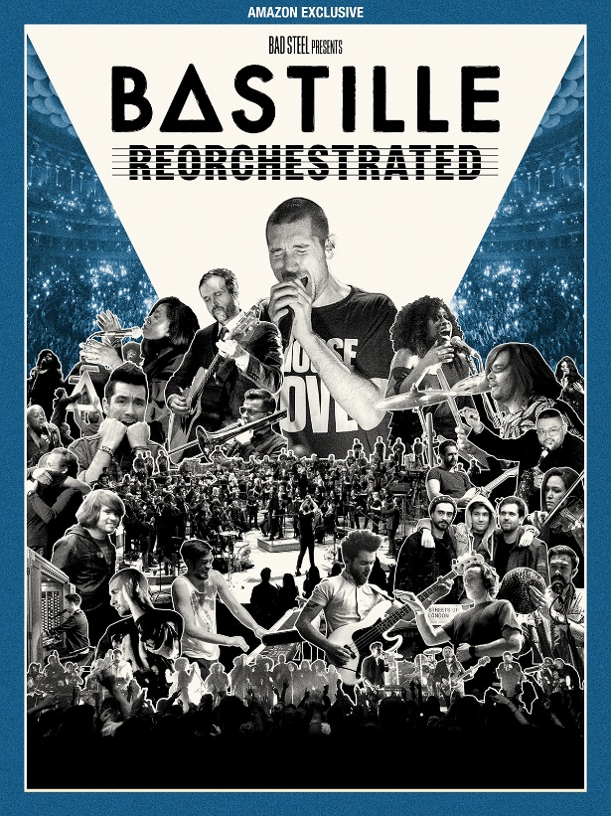

Bastille ReOrchestrated
A new documentary film premieres on Amazon Prime Video – Wednesday 10th February 2021

Watch the trailer here

ReOrchestrated is a feature-length documentary film starring Bastille, arriving worldwide via Amazon Prime Video on Wednesday 10th, 2021. Fans can also stream the Amazon Original track ‘Warmth’, which features during the opening sequence of documentary film, exclusively on Amazon Music. Listen here.

From humble underdog origins, through to a number one debut album, BRITs and Grammy nods, and huge crowds in arenas and festivals all over the world, Bastille’s story pivoted with a career-shifting show at London’s Union Chapel during 2017.

In an intimate appearance for charity, rather than simply presenting the band as it was then, Dan Smith, Kyle Simmons, Will Farquarson and Woody enlisted a choir and strings/brass ensemble, rearranging and reinventing their entire set-list for the occasion.

Unknowingly at the time, what was to spring from that performance was to flip the band’s perspective forever - igniting an insatiable desire to collaborate with an ever-evolving cast of world class, classically trained musicians across a series of increasingly high profile appearances in globally revered venues.

Exploring themes of drive, motivation, anxiety, and imposter syndrome, ReOrchestrated is a revelatory and inspiring watch for anyone that wishes to understand what it takes to keep things gripping within the construct of a band format, and the risk-taking required to surprise and enchant both the members involved as well as an audience alike.

Sourced from hundreds of hours of unseen archive and all-new conversations recently captured during the pandemic, the film features bracingly honest insights from all four band members plus characters inextricably linked to the group’s time thus far. It charts the very beginning of the band’s foundations all the way through their three albums to date, via landmark, full orchestra appearances at Royal Albert Hall in London, Elbphilharmonie in Hamburg, and The London Palladium, not to mention the inevitable tensions encountered en route.

The film is co-directed by long-time band collaborator Tom Middleton and Toby L (Foals - ‘Rip Up The Road’), an Up The Game film produced in association with Crooked Cynics, EMI and Amazon Music.

Amazon Music listeners can find the track ‘Warmth’ from ReOrchestrated exclusively on Amazon Music. Customers can also simply ask, "Alexa play the Amazon Original album by Bastille" in the Amazon Music app for iOS and Android and on Alexa-enabled devices. In addition to the album, Amazon Music listeners can access hundreds of Amazon Originals featuring both emerging and established artists across numerous genres, available to stream and purchase only on Amazon Music.

Fans can also listen to Bastille's Amazon Original, orchestral version of their song ‘Million Pieces’ with The Chamber Orchestra of London which was recorded at the prestigious Abbey Road studios for Amazon Music. Listen here.

http://instagram.com/bastilledan/
https://twitter.com/bastilledan
http://www.bastillebastille.com/

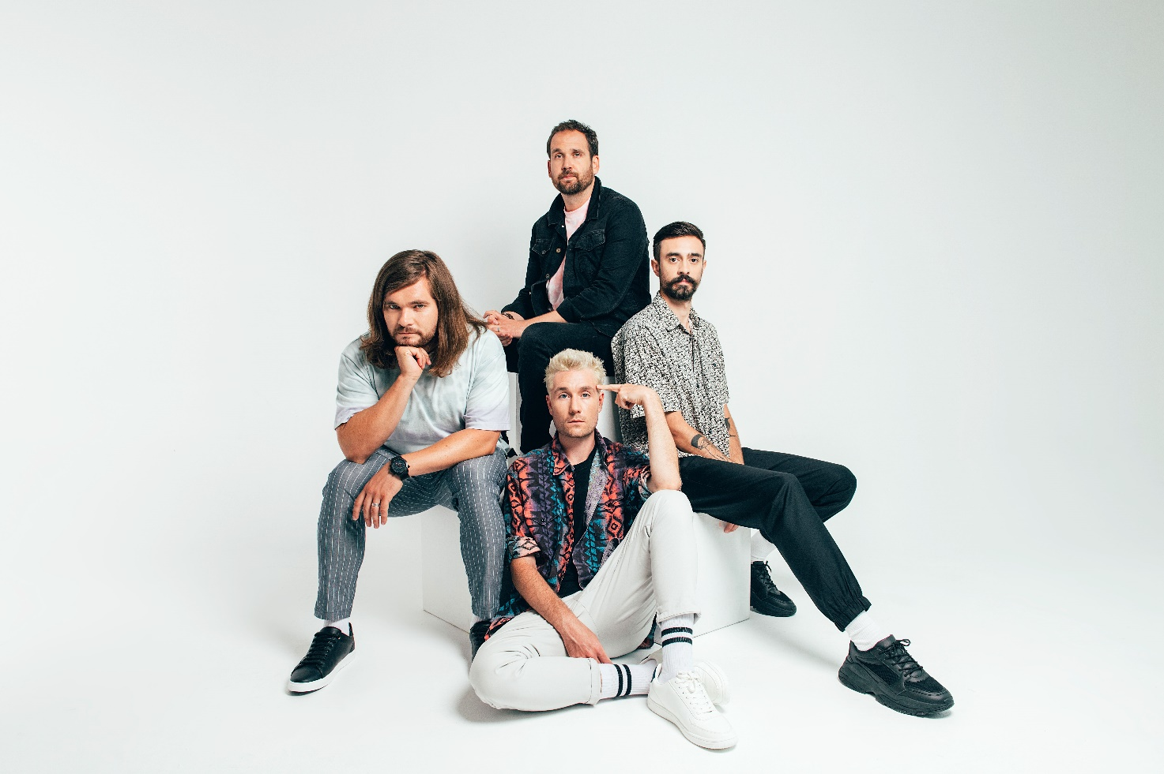

For more information and press enquiries please contact
Jenny Entwistle
Jenny@chuffmedia.com

