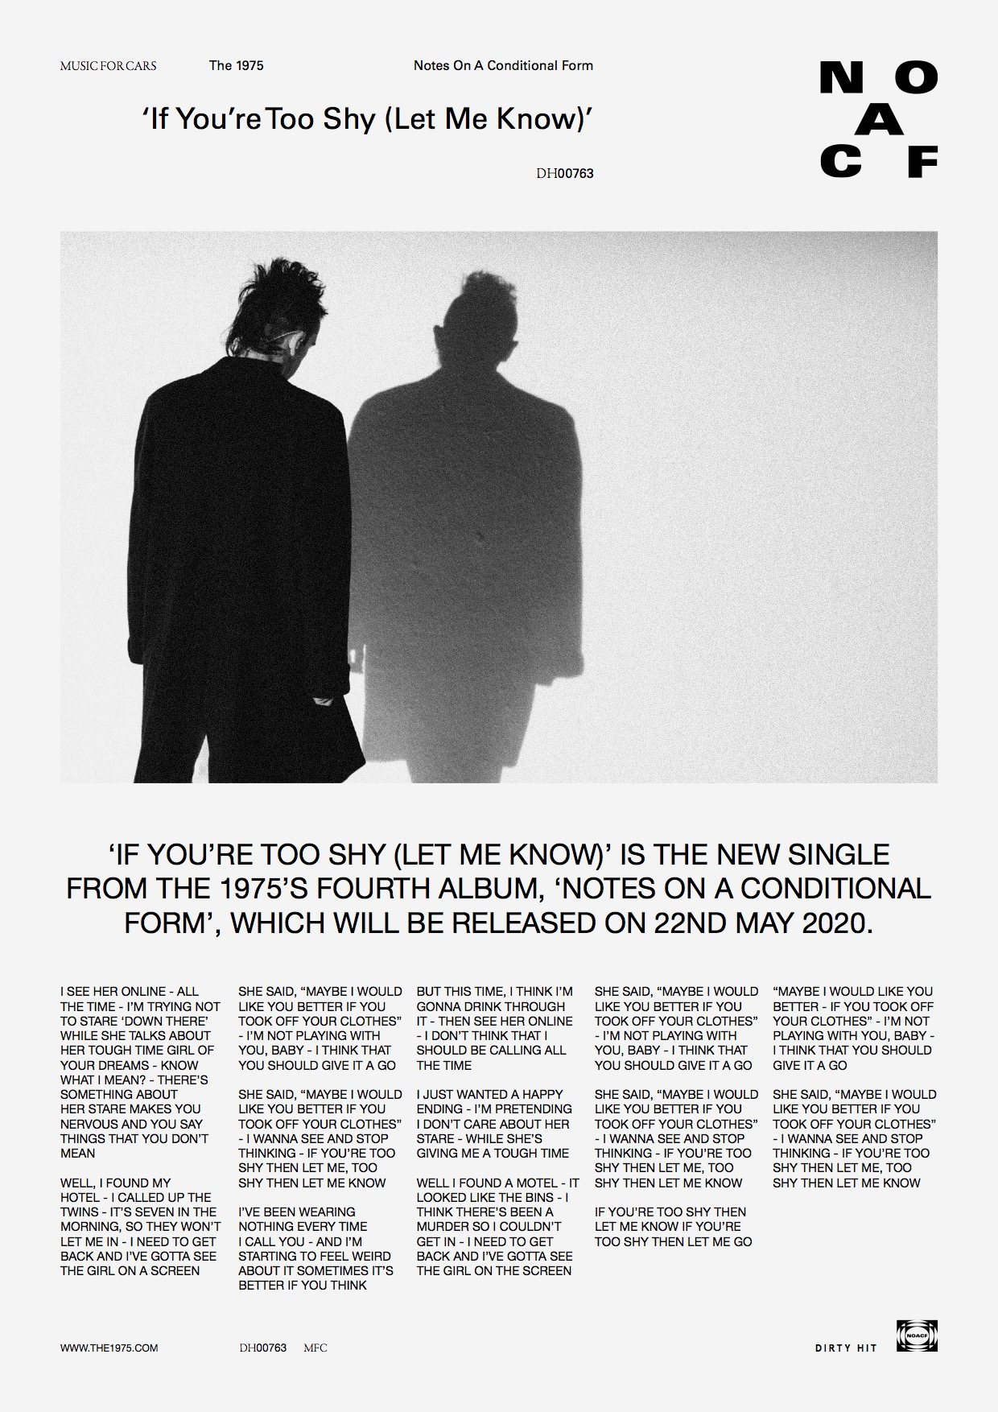

For all press enquiries please contact:

Warren Higgins
warren@chuffmedia.com
020 8281 0989

