BASTILLE RELEASE NEW TRACK "WHAT YOU GONNA DO???" FT. GRAHAM COXON

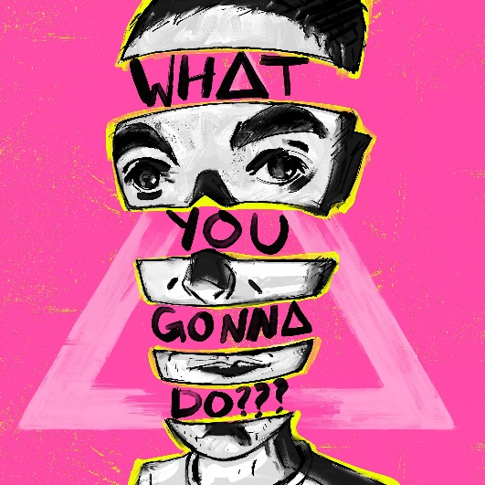

LISTEN HERE
WATCH HERE

Bastille’s electrifying new song might feel like a bit of a surprise release, not least to the band themselves, but as frontman Dan Smith says: “We finished the song and it felt urgent. We didn’t want to sit on it.”

A thunderous, furious short sharp shock, WHAT YOU GONNA DO??? comes after the dust settled on the band’s acclaimed third album Doom Days — the final instalment in a trilogy that’s spanned eight years and brought Bastille multi-platinum sales, global success and a position as one of the world’s most streamed bands. Fans may have grown accustomed to albums arriving with fully formed, meticulously executed creative ecosystems, but this time it’s all change.

“This next phase feels like a new beginning. It’s about completely tearing up our process, being spontaneous and starting again,” Dan states.
“We’re just really excited by the new songs. I think we’re making some of the best music we’ve ever made. We want to put it out now and not wait for the whole album to be done before anyone starts to hear it. This is about where we are now and hearing us in real-time”

Produced by Dan and Mark Crew it’ll surprise anyone who thought they knew what to expect from the band - The song features Graham Coxon on guitar and vocals.

The tongue-in-cheek chorus of WHAT YOU GONNA DO??? explores a frustration with the attention economy in which our ears and eyes are fiercely fought over, yet so few use it for anything worthwhile. “Whether we’re outside or online we’re perpetually hit by so many people vying for our attention,” Dan adds, “but we’re just left rolling our eyes at how rarely it’s for anything that decent or funny.” The track was written before 2020 turned on its head, but it’s hard to ignore the poignancy of a song that questions the squandered attention of billions of captive eyeballs.

The track’s extraordinary video sees Bastille collaborating with Rezza a British/Iranian, London-based animator who brings a seismic visual shift for Bastille: the video is a mash up of mixed media using illustration, photography and live action which resulted in a unique and innovative style that is winningly berserk.

Sonically WHAT YOU GONNA DO??? is either the first clue to a brand new chapter for Bastille or a complete red herring. Either way it marks the beginning of an exciting and surprising new era for the band.
http://instagram.com/bastilledan/
https://twitter.com/bastilledan
http://www.bastillebastille.com/

For more information and press enquiries please contact:
Warren Higgins
warren@chuffmedia.com
020 8281 0989

