MYSTERY JETS
NEW ALBUM ‘A BILLION HEARTBEATS’ OUT ON CD AND VINYL TODAY
NEW VIDEO FOR ‘CAMPFIRE SONG’
WATCH HERE
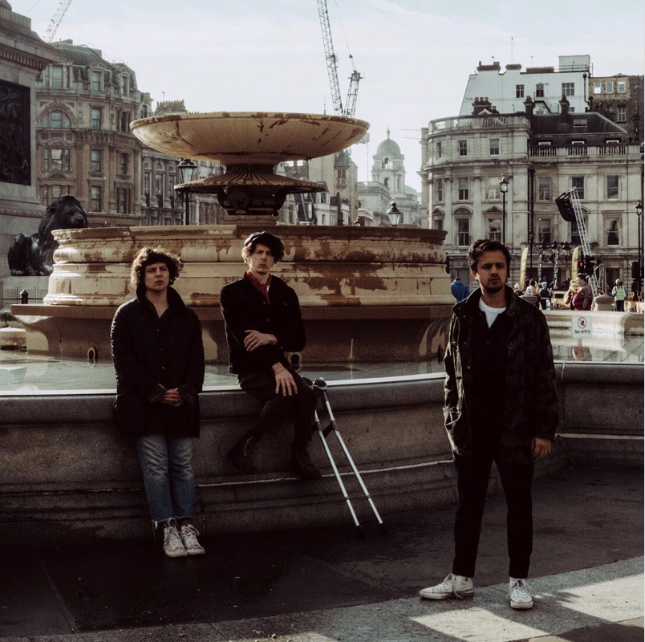

“the sound of a group breaking out of their shell and demanding to be heard” – The Telegraph ★★★★★
“This is an album which sounds as big as its subject matter” - The Independent ★★★★
“big punchy tunes pinned down by big punchy themes” - Q ★★★★
“It all gives renewed purpose to a much-loved British band.” – The Times ★★★★
“prescient politics… terrifyingly timely” - Sunday Times Culture
“Busting with indignant rage, riffs and gorgeous melodies” – The Sun ★★★★
“Uplifting epics and hopeful message” – Daily Star ★★★★
“grungy riffs and a rousing call for fightback” – Evening Standard ★★★★
“Harrison shines as one of Britain’s truly great but underrated lyricists” – NME ★★★★
“an undoubtably influential album”- DIY ★★★★
“One of the most essential indie albums of recent years” – Gigwise 9/10
“Mystery Jets at their best” – The Line Of Best Fit 9/10
“A special achievement from a national treasure” – Dork ★★★★
“Musically, it is arguably the best thing the band have done” – Music OMH ★★★★.5
Today, Mystery Jets release their sixth studio album, ‘A Billion Heartbeats’ physically on CD and vinyl. The album was released digitally on 3rd April. The band will be doing a virtual in-store tonight in partnership with Banquet Records.

The band have also today released the new video for latest single ‘Campfire Song’: a song providing an account of trying to keep hold of yourself and what you believe amidst chaos, lyrics that are eerily resonant in the current climate.
Mystery Jets recently announced details of their podcast, ‘Things Worth Fighting For’. The podcast explores stories of resilience from writers, musicians, comedians and activists who have not only had to overcome adversity but have used their voice to empower others in the fight for social justice. In this week’s episode the band sit down with author Nikesh Shukla, named by Time Magazine as ‘’one of the twelve leaders shaping the next generation of artists’,’ to find out how ‘The Good Immigrant’ has helped change the face of publishing in the UK, and the opening thought features journalist and author Reni Eddo-Lodge with an exclusive reading from her No.1 bestseller ‘Why I’m No Longer Talking To White People About Race’. Next week’s episode will focus on Protest Culture and will feature Billy Bragg and Ed O’Brien from Radiohead.

We increasingly hear from musicians that music should be an escape these days - that there’s enough suffering in the world, enough misery on the news, without writings songs about it too. A Billion Heartbeats makes all that sound like a bit of a cop-out. These are songs of protest that get the heart racing in joy; high on hope, and serious in their message. Proof, basically, that music speaks louder than words.

Tracklisting:
1. Screwdriver
2. Petty Drone
3. History Has Its Eyes On You
4. A Billion Heartbeats
5. Endless City
6. Hospital Radio
7. Cenotaph
8. Campfire Song
9. Watching Yourself Disappear
10. Wrong Side Of The Tracks
Keep track of Mystery Jets here:
Twitter | Facebook | Instagram

For all press enquiries please contact:

Warren Higgins
warren@chuffmedia.com
020 8281 0989

